Hotel Reservation Software

Group 1 Project Design, Rev 5

CMSC 495 ( 6380) Current Trends and Projects in Computer Science (2205)

University of Maryland Global Campus

Summer 2020

Professor Hung Dao

[06/16/2020]

Group 1 Members:

Jacob Valentine

Leonardo Elias

Emmanuel Girin

Marques Young

Revision Table

|  |  |  |  |
| --- | --- | --- | --- |
| **Revision** | **Date** | **Description** | **Contributor** |
| 0 | 06/14/2020 | Creating Document, Cover Page, Revision Table, Event Trace Section, and Class Designs section | Jacob Valentine |
| 1 | 06/15/2020 | Added Class Design Details | Emmanuel Girin |
| 2 | 06/16/2020 | Finalizing Class Designs, including GUI design | Emmanuel Girin |
| 3 | 06/16/2020 | Startup/ Shutdown | Leonardo Elias |
| 4 | 06/16/2020 | Added Normal Scenarios Pre/Post Conditions, Descriptions, and steps | Marques Young, Jacob Valentine |
| 5 | 06/16/2020 | Added Event Trace Diagrams | Leonardo Elias |
| 6. | 06/16/2020 | Risks/Mitigation | Marques Young |
|  |  |  |  |

# Event Trace Diagrams

## Normal Scenarios

Scenario 1 – Startup

Description:

1. The user opens the application.
2. GUI prompts for login.
3. Check if the database is up and running.
4. It returns the login page.

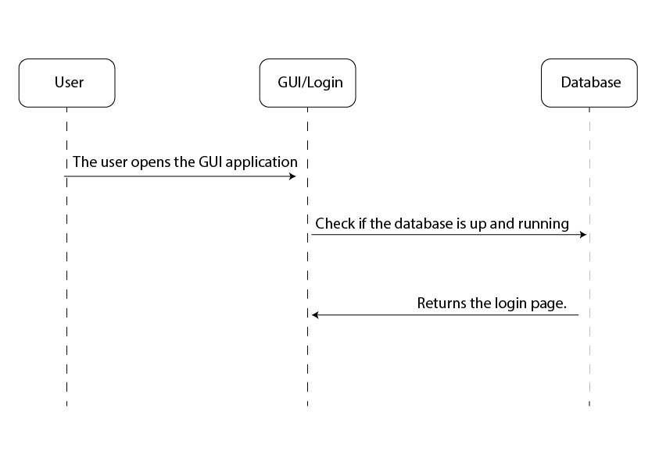

Scenario 2 – Shutdown

Description:

1. The user requests to close the application.
2. End connection with the database.
3. Gui application shuts down.

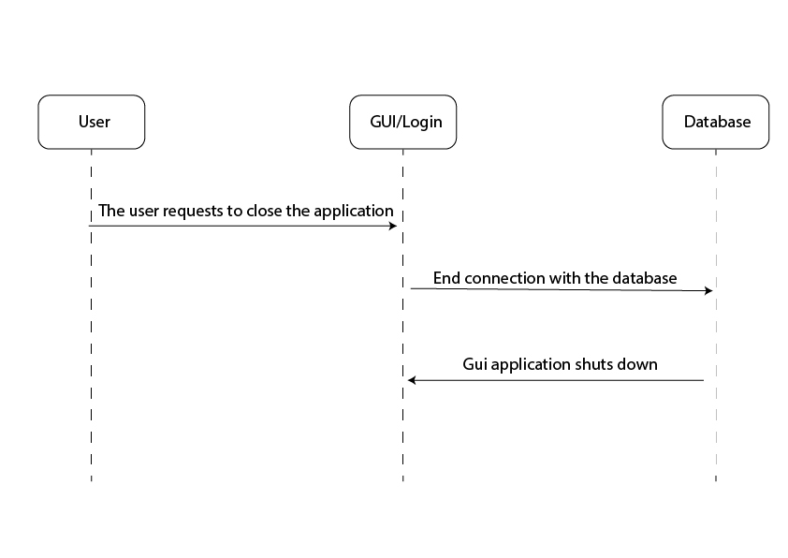

Scenario 3 – Create new Customer

Pre-condition: the user selects the “Create new Customer” option from the Customer Manager

Post-Condition: The customer entry is added to the customerRecords and the user is shown a confirmation message.

Description: After logging in, the user can create a new Customer entry to be saved into the database by selecting the corresponding option, and inputting the required customer information (Name, date of birth, contact information, etc.).

Steps:

1. [User -> input/gui] User selects the “Create New Customer” option on the customer manager GUI
2. [Input/Gui -> CustomerManager] request is passed to the CustomerManager system for processing
3. [CustomerManager -> Input/Gui] Request message for information is passed to input
4. [Input/gui -> User] User is prompted to enter the name, date of birth, Address, and contact information regarding the new customer.
5. [User -> Input/GUI] User inputs the required information and hits the confirmation button
6. [Input/GUI -> CustomerManager] Inputted information is passed to the Customer Manager
7. [CustomerManager -> CustomerRecords] A new Customer instance is created and passed to customerRecords to save into the database.
8. [CustomerRecords -> CustomerManager] a Confirmation is passed
9. [CustomerManager -> Input/gui] a confirmation is passed
10. [Input/GUI -> User] The user is presented a message confirming the new customer was added to the database.

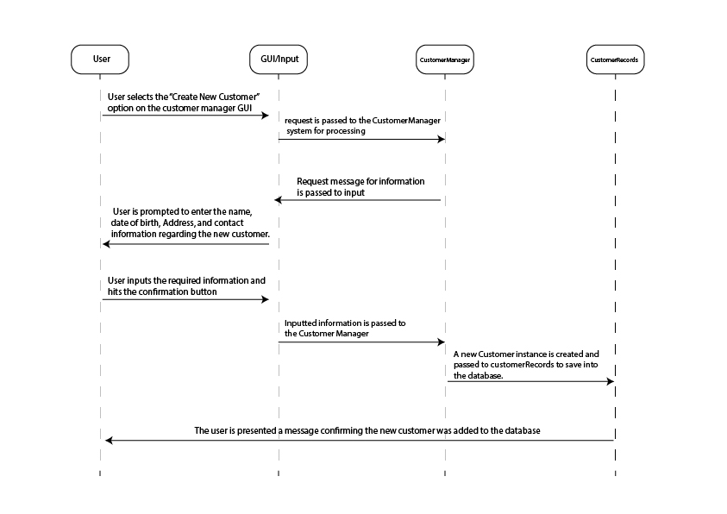

Scenario 4 – Select an existing Customer

Pre-Condition: The user inputs the account information linked to an existing customer

Post-Condition: The selected customer is selected as the active customer, and the reservation manager is displayed.

Description: The user selects a customer from the database of customers and manages that customers' existing and future reservations from there.

Steps:

1. [User -> input/gui] User inputs the information for an existing customer
2. [Input/Gui -> CustomerManager] the information is passed to the CustomerManager system for verification
3. [CustomerManger -> CustomerRecords] CustomerManager checks the CustomerRecords database for the given customer.
4. [CustomerRecords -> CustomerManager] CustomerRecords passes the customer information
5. [CustomerManager -> Input/Gui] CustomerManager verifies the customer account, and passes the customer information to Input/GUI
6. [Input/gui -> User] The customer is set as the active customer, and the user is presented with the Reservation Manager screen.

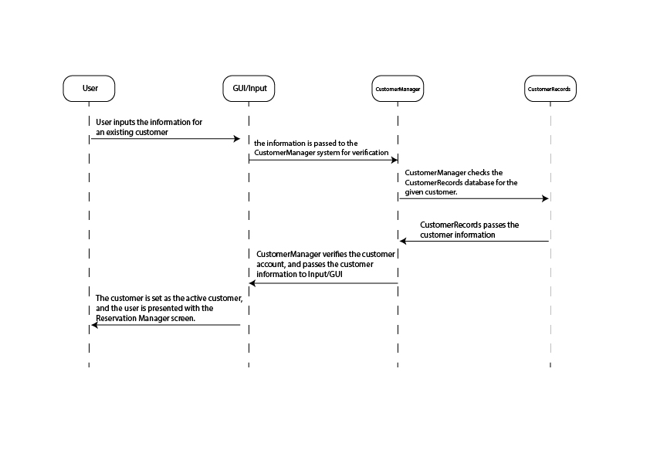

Scenario 5 – Update Customer Entry

Pre-Condition: The user inputs the information linked to an existing customer entry, and selects the “Modify Customer Account” option.

Post-Condition: The Customer entry of the CustomerRecords database is updated and the user is given a confirmation message.

Description: The user can modify an existing customer entry with updated information, should they need to.

Steps:

1. [User -> input/gui] User inputs the information for an existing customer and selects the modify customer option
2. [Input/gui -> User] User is prompted to enter the new information for the customer entry
3. [User -> Input/gui] User inputs the new information
4. [Input/Gui -> CustomerManager] the information is passed to the CustomerManager system
5. [CustomerManger -> CustomerRecords] CustomerManager checks the CustomerRecords database for the given customer.
6. [CustomerRecords -> CustomerManager] CustomerRecords passes the customer information
7. [CustomerManger -> CustomerRecords] CustomerManager modifies the entry with the new informaiton and saves it to the CustomerRecords database
8. [CustomerRecords -> CustomerManager] passes a confirmation
9. [CustomerManager -> Input/Gui] CustomerManager passes a confirmation of an updated customer entry
10. [Input/gui -> User] The user is given a confirmation message.

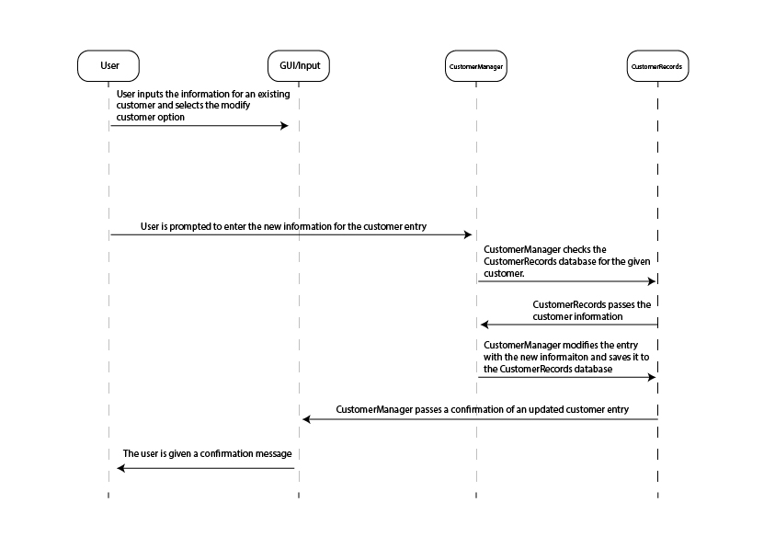

Scenario 6 – Lookup reservation by customer and checkin date

Pre-Condition: The user inputs the checkin date for a reservation linked to the active customer

Post-Condition: The information for a Reservation linked to the active customer is displayed and selected.

Description: The user is able to look up a room reservation by customer for ease of use.

Steps:

1. [User -> Input/GUI] User inputs a checkin date
2. [Input/GUI -> ReservationManager] the request, active Customer, and checkin date is passed to the Reservation manager.
3. [ReservationManager -> Reservation Records] Querries the database for reservation data linked to the customer and date
4. [ReservationRecords -> ReservationManager] returns reservation data
5. [Reservation Manager -> Input/GUI] sends confirmation of request and sets the reservation as the active reservation
6. [Input/GUI -> User] the selected reservation’s information is displayed to the user.

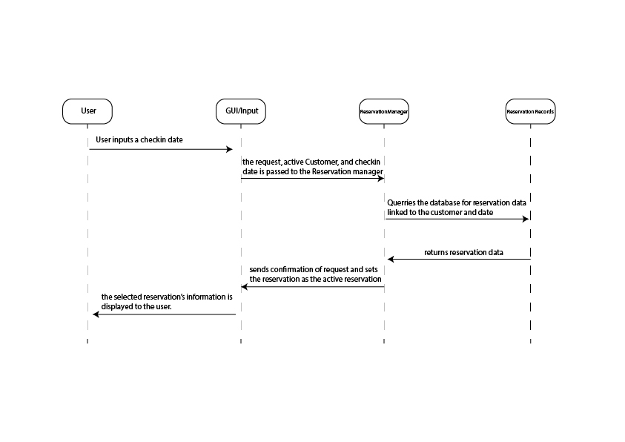

Scenario 7 – Lookup reservation by ID

Pre-Condition: The user inputs an ID to search for a reservation.

Post-Condition: The reservation is displayed and selected based on the entered ID.

Description: This allows a user to look up a reservation by entering an ID instead of using a customer’s name.

Steps:

1. [User -> Input/GUI] User inputs a reservation ID
2. [Input/GUI -> ReservationManager] the request, active Customer, and reservation ID is passed to the Reservation manager.
3. [ReservationManager -> Reservation Records] Querries the database for reservation data linked to the customer and reservation ID
4. [ReservationRecords -> ReservationManager] returns reservation data
5. [Reservation Manager -> Input/GUI] sends confirmation of request and sets the reservation as the active reservation
6. [Input/GUI -> User] the selected reservation’s information is displayed to the user.

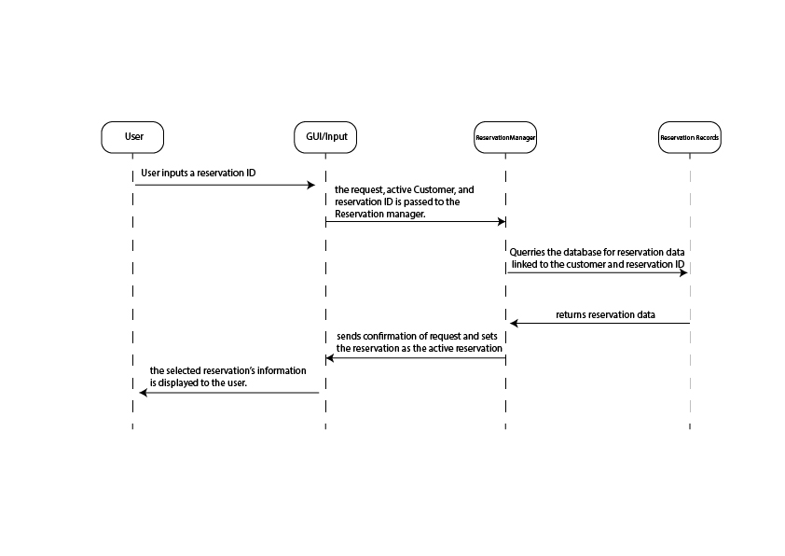

Scenario 8 – Delete Reservation

Pre-Condition: The user selects the “Delete Reservation” option with an active reservation selected.

Post-Condition: the user is presented with confirmation that the reservation has been deleted.

Description: This allows a user (manager) to delete an existing reservation if the need arises.

Steps:

1. [User -> Input/GUI] User selects “Delete Reservation”
2. [Input/GUI -> ReservationManager] request is passed
3. [ReservationManager -> ReservationRecords] the databased is quarried for the reservation entry
4. [ReservationRecords -> ReservationManager] verified that the entry exists
5. [ReservationManager -> ReservationRecords] request to delete the entry
6. [ReservationRecords -> ReservationManager] confirmation that the entry has been deleted
7. [ReservationManager -> Input/GUI] Confirmation is passed
8. [Input/GUI -> User] User is displayed a message confirming that the reservation has been deleted.

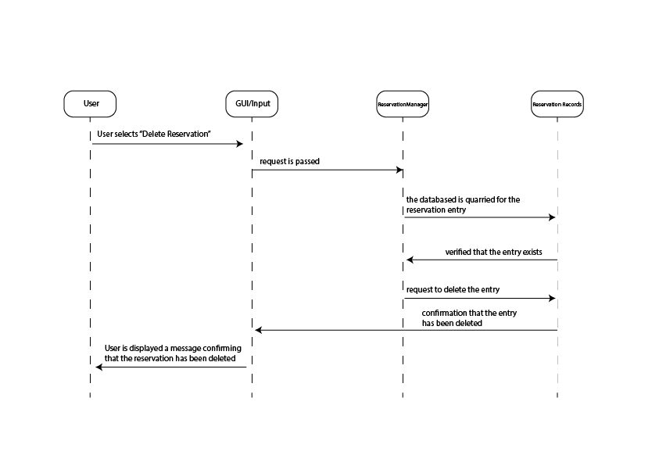

Scenario 9 – Lookup available Rooms

Pre-Condition: The user inputs a checkin date, room style (number of beds), has an active customer selected, and selects “Display available rooms”

Post-Condition: The user is presented a list of information for all rooms not reserved

Description: The user can easily see what rooms of a given style are available for reservation on a given day.

Steps:

1. [User -> Input/GUI] user inputs a checkin date and room style number
2. [Input/GUI -> RoomManger] information and request is passed
3. [RoomManager -> RoomRecords] Queries the database for rooms of the given style
4. [RoomRecords -> RoomManager] returns array of rooms matching the style
5. [RoomManager -> Input/GUI] parses the array for Rooms that are not reserved o the given Checkin date, and passes the array of those rooms to Input
6. [Input/GUI -> User] The user is presented a list of information related to each available room.

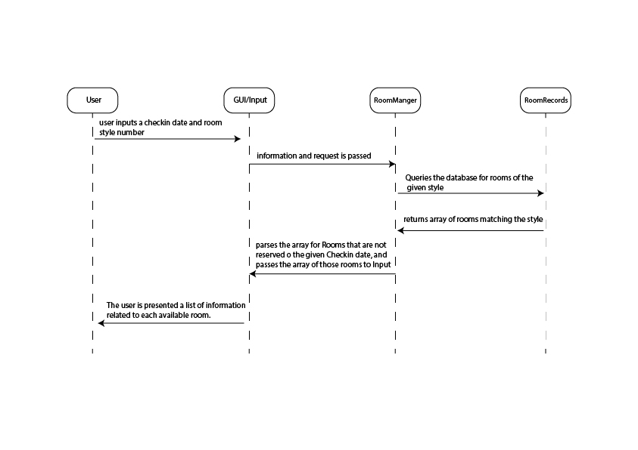

Scenario 10 – Reserve Room

Pre-Condition: User inputs the Room ID for an available room, checkin date, and checkout date, with an active customer selected.

Post-Condition: The new reservation is made and the user is shown a confirmation message.

Description: The user can reserve available rooms for customers within given checkin and checkout days.

Steps:

1. [User -> Inputs/GUI] the user inputs a Room ID, checkin date, Checkout date, and presses the “Make reservation” option
2. [Input/GUI -> ReservationManager] information is passed
3. [ReservationManager -> ReservationRecords] The information is made into a Reservation entry and saved to the database
4. [ReservationRecords -> ReservationManager] The database passes a confirmation that the record was saved successfully
5. [ReservationManager -> Input/GUI] The confirmation is passed to input
6. [Input/GUI -> User] The user is presented a message confirming that the reservation is saved.

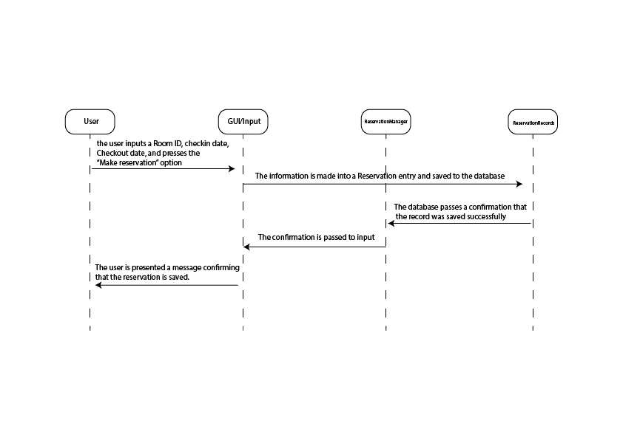

## Error Handling Scenarios

Scenario 1 – Login Failure

Pre-Condition: User inputs invalid login information

Post-Condition: User will be presented with an “Invalid Login”

Description: The user provides an invalid username or password when prompted for a login. If the username/Password combination is not found, an error message will be displayed to the user telling them that either the username or password is incorrect, and will be prompted to enter a valid login.

Steps:

1. [User -> input/gui] user inputs invalid login information
2. [input/gui -> Logon] the input login information will be passed to logon to verify
3. [logon -> UserRecords] logon will query UserRecords for existence of employee by empID
4. [UserRecords -> Logon] UserRecords will not have that entry, and will return false
5. [logon -> input/gui] Logon will return false, and prompt an error message
6. [input/gui -> user] User will be presented a login error message and prompted to enter a valid login.

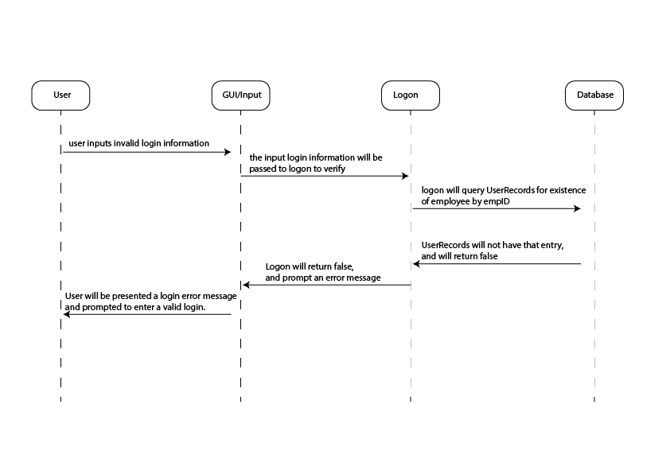

Scenario 2 – Database disconnected

Pre-Condition: The User attempts to login, but the User lookup database is inaccessible

Post-Condition: The user will be given an error message stating that the application could not access the database, and to try again later.

Description:

Steps:

1. [User -> Input/gui] user inputs login information
2. [input/gui -> Logon] the input login information will be passed to logon to verify
3. [Logon -> UserRecords] Logon will query Userrecords
4. [UserRecords -/> Logon] Database is inaccessible and/or disconnected
5. [Logon -> input/gui] Pass Database error exception to input
6. [input/gui -> user] Display Error message stating that the system could not connect to the database.

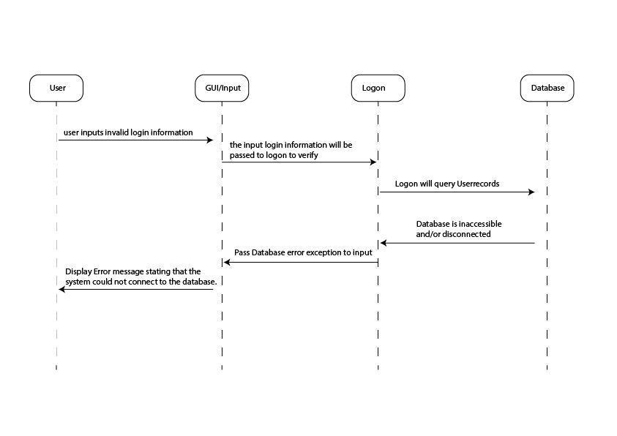

Class Designs

Input / GUI Subsystem

This class writes the whole Graphical In / Out interface for the USER. As this class may develop into further classes to avoid becoming too large, we have loosely defined the graphics pseudocode to describe the flow.

This GUI scenario assumes a typical flow through the program with Main Features highlighted

1. load LoginGUI: Login FORM asking for Employee ID and Password
2. user submits form through button: data is passed to validateCredentials
3. Login is authenticated -> User is brought to CustomerSelect Page
4. User Selects Existing Customer or New Customer
5. User Selects New Customer -> New Customer Form is loaded
6. User enters customer information selects button to submit form data
7. Data is passed to CustomerManager, which creates a new customer in database
8. ReservationSelection is Displayed – Asking user to choose between existing or new reservation
9. User chooses New Reservation Button
10. Load ReservationCreate Form – with form for checkin, checkout, room type
11. Create RoomsManager Object to find AvailableRooms and pass info back
12. Display AvailableRooms to User for Selection
13. User Selects Available Rooms, which are passed to Reservation Manager to create New Reservation
14. The info for the reservation is displayed and if user hits finalize, the reservation will get created in the database and receipt info will be displayed.

The GUI for this program will have a main frame created in the first display method of the class below. The main frame will have an exit button. IT will leave the entire center for panels. Each display call will update the panel in the center, simulating a new screen.

**class HotelReservationGUI** {

Frame frame;

ReservationManager reservMgr;

CustomerManager custMgr;

RoomManager roomMgr;

Login logon;

int LogonAttempts = 0;

//methods

static void main(int param) {

HotelReservationGUI a = new HotelReservationGUI;

a.displayLogin();

}

void displayLogin(){

create Frame with exit button

create panel with form

//form with empID, password label and textboxes and a button to login

render loginGUI;

If (empID has characters & password has characters)

enable Login Button;

Login Button onButtonClick

{

else If ( logon.ValidateCredentials(empID, password) )

displayCustomerManager();

else {

//error Message

display logon.getMessage();

//reset display

displayLogin();

logOnAttempts++;

//check for too many login attempts

If (logOnAttempts >= 5) {

Display Error Message;

Exit System;

}

}

}

} //end method

void displayCustomerManager{

render selectCustomerGUI

button newCustomer

button existingCustomer

custMgr = new CustomerManager();

if User chooses NewCustomer Button

displayNewCustomerForm();

else if User chooses existingCustomer Button

displayExistingCustomerForm();

}

void displayNewCustomerForm{

render newCustomerForm

Form Displays textboxes for firstName, lastName, street, city, state, country, phone,

email;

Form Data is input into String Array customerData;

custMgr.createNewCustomer(customerData);

displayReservationManager();

}//end method

void displayExistingCustomerForm{

render existingCustomerForm

Form Displays textboxes for firstName, lastName, phone, email;

button LookUpByName, LookUpByEmail, LookUpByPhone;

boolean continue = false;

//decide which lookUpToPerform

LookUpByName Clicked {

if (firstName & lastName are filled)

continue = custMgr.lookUpCustomerByName(first, last);

if(continue)

displayReservationManager();

else

display “Failed to find customer. Exit or Try Again”

}

LookUpByPhone clicked {

if (phone is filled)

continue = custMgr.lookUpCustomerByPhone(phone);

if(continue)

displayReservationManager();

else

display “Failed to find customer. Exit or Try Again”

}

LookUpByEmail clicked {

if(email is filled)

continue = custMgr.lookUpCustomerByEmail(email);

if(continue)

displayReservationManager();

else

display “Failed to find customer. Exit or Try Again”

}

}//end method

void displayReservationManager {

renderReservationManager

button NewReservation, Existing Reservation;

display buttons

if user clicks NewReservation

displayNewReservation();

if user clicks ExistingReservation

displayExistingReservation();

}//end method

void displayExistingReservation{

render ExistingReservation

Form asking for CheckInDate, reservation number;

button LookUpbyName, LookUpByNumber;

if user clicks LookUpByName {

try {

reserveMgr.LookUpByName(custMGR.getCustID(), checkInDate);

displayReservationData();

}

catch Exception Display Message to User

}

if user clicks LookUpByNumber {

try {

reserveMgr.LookUpByReservation(reservationNumber);

displayReservationData();

}

catch Exception Display Message to User

}

}//end method

void displayReservationData

{

button ModifyReservation, DeleteReservation

displays reserveMGR.getCurrentReservation.toString() in a textbox

if ModifyReservation button is clicked {

//deletes existing reservation

reserveMgr.deleteReservation();

//navigate to create a New Reservation, replacing old one

displayNewReservation();

}

if DeleteReservation button is clicked {

reserveMgr.deleteReservation();

//navigate back to Customer Manager Screen to start over

displayCustomerManager();

}

}//end method

void displayNewReservation {

render NewReservation

Form Asking for: checkIn, checkOut, # of Guests,Dropdown Preferred Room Type, # of

rooms;

roomsMgr = new RoomManager (checkIn, checkOut, Prefered Type, numRooms)

try {

roomsMgr.SearchForAvailableRooms();

//if no exceptions thrown then rooms have been found

reserveMGR.createReservation(checkIn, checkOut, int numGuests,

roomsMgr.getSelectedRooms());

displayFinalizeReservation();

}

catch Exceptions and display appropriate Message, redisplay Form

}//end method

void displayFinalizeReservation(); {

button finalizeReservation, cancel;

textbox reservationDetails

Display reserveMGR.getCurrentReservation().toString() in reservationDetails

if finalizeReservation is clicked {

reserveMGR.finalizeReservation

//shows the newly created Reservation ID.

// Allows user to print reservation details

display reserveMGR.getCurrentReservation().toString() in textbox

display button exit

if exit is clicked

SystemExit();

}

if cancel is clicked {

//return to CustomerManager page

displayCustomerManager();

}

}//end method

}//end class  
  
Logon Subsystem

**static class Login** {

//data  
private String message;

//methods

String getMessage() {

return message;

}//end method

boolean ValidateCredentials(String empID, String password)) {

connect to database

query UserRecords for existence of employee by empID

If (database returns true) {

compare (password) to UserRecord employee’s password

If (database returns true) {

return true;

}//end inner if  
Else {

message = “Error Incorrect Password”;

return false;

}

} //end outer if

Else {

message = “Incorect EmployeeID”;

return false;

}

} //end method

}//end class

Customer Subsystem

This subsystem combines previous subsystems outlined for customers into 2 classes. The customer manager class accesses the database to look up an existing customer, modify existing customer data, or create a new customer. This customer manager class combines our 2 previous subsystems of creating a new customer and looking up an existing one. The customer object is where the data is stored either from input or from the database depending on the method needed.

**class CustomerManager** {

//data

private Customer currentCustomer;

//methods

void createCustomer (StringArray CustomerData) {

currentCustomer = new Customer(CustomerData);

connect to Database customerRecords;

//Adds all of the data points into Database Table CustomerRecords

Create New Row in customerRecords(

currentCustomer.getFirstName(),

currentCustomer.getlastName(),

currentCustomer.getDob(),

currentCustomer.getstreet(),

currentCustomer.getCity(),

currentCustomer.getState(),

currentCustomer.getCountry(),

currentCustomer.getPhone(),

currentCustomer.getEmail()

);

//Retrieves the unique key from the database

currentCustomer.setCustomerID(retrieve customerID from customerRecords);

}//end method

boolean lookUpCustomerByName(String firstName, lastName) {

connect to Database customerRecords

querry customerRecords Table for match of firstName, lastName

if (matchFound){

retrieve customerData from Database

StringArray customerData = new StringArray size 10);

for each element in customerData {

add corresponding column info

}

currentCustomer = new Customer(customerData);

return true;

}

else

return false; //lets calling method know that lookUpFailed

} //end method

boolean lookUpCustomerByEmail(String email) {

connect to Database customerRecords

querry customerRecords Table for match of email

if (matchFound){

retrieve customerData from Database

StringArray customerData = new StringArray size 10);

for each element in customerData {

add corresponding column info

}

currentCustomer = new Customer(customerData);

return true;

}

else

return false; //look up Failed

} //end method

boolean lookUpCustomerByPhone(String phoneNumber) {

connect to Database customerRecords

querry customerRecords Table for match of phoneNumber

if (matchFound){

retrieve customerData from Database

StringArray customerData = new StringArray size 9);

for each element in customerData {

add corresponding column info

}

currentCustomer = new Customer(customerData);

return true;

}

else

return false; // look up Failed

} //end method

void modifyCustomer(StringArray CustomerData){

connect to customerRecords table;

query by CurrentCustomer.getCustomerID();

for each element in CustomerData {

Modify Column in current Customer Record with CustomerData[element];

}

}//end method

}//end class

**class Customer** {

Private String CustomerID, firstName, lastName;

Private String dateOfBirth; // YYYY:MM:DD format

Private String street, city, state, country;

Private String phone, email //phone # will be formatted and validated possibly

//Constructor Takes a String Array for each point of data.

Public Customer (StringArray CustomerData) {

customerID = customerData[0]

FirstName = CustomerData[1];

LastName = CustomerData[2];  
dateOfBirth = CustomerData[3];

Street1 = CustomerData[4];

City = CustomerData[5];

State = CustomerData[6];

Country = CustomerData[7];

phone = CustomerData[8];

email = CustomerData[9];

}

public toString() {

Display class variables;

}

//Methods to set Data

Void setCustomerID(String str) {

customerID = str;

}

Void setFirstName (String str) {

firstName = str;

}

Void setLastName (String str) {

lastName = str;

}

Void setDateOfBirth (Date dob) {

DateOfBirth = dob;

}

Void setStreet(String str) {

street1 = str;

}

Void setCity(string str) {

city = str;

}

Void setState(String str) {

state = str;

}

Void setCountry(String str) {

country = str;

}

Void setEmail(String str) {

email = str;

}

Void setPhone(String str) {

phone = str;

}

//Methods to get Data

String getCustomerID(){

return customerID;

}

String getFirstName () {

return firstName;

}

String getLastName() {

return lastName;

}

String getDob() {

Return dateOfBirth;

}

String getStreet() {

return street1;

}

String getCity () {

return city;

}

String getState () {

return state;

}

String getCountry() {

return country;

}

String getPhone() {

return phone;

}

String getEmail () {

return email;

}

} //end Class

### Reservation Subsystem

The reservation subsystem combines 4 of our previous subsystems into 2 classes. The reservation class holds the data for all the reservations. The reservationManager class interfaces with the input and the database to create a reservation object and retrieve data from the database or upload data to the database.

**class Reservation** {

//data

private int ReservationID, customerID, numOfGuests;

private double totalCost;

private Int Array roomIDs;

private Date checkIn, checkOut;

private final taxRate = .10; //taxRate is set in this program

//methods

//constructor for reservations existing in database

public Reservation(int reservation, int cust, Int Array rooms, int cost, int guests,

date in, Date out) {

reservationID = reservation;

customerID = cust;

numOfGuests = guest;

roomIDs = rooms;

totalCost= cost * (1 + taxrate);

checkIn = in;

checkOut = out;

}//end constructor

public toString() {

Display class variables;

}

//get methods for all data

int getReservationID() {

return ReservationID

}

int getCustomerID() {

return customerID

}

int getNumOfGuests() {

return numOfGuests;

}

intArray getRoomIDS() {

return roomIDs;

}

Date getCheckIn() {

return checkIn;

}

Date getCheckOut() {

return checkOut

}

} //end class

**class ReservationManager {**

//data

Reservation currentReservation;

//methods

void createReservation(Date checkIn, Date checkOut, int numGuests, int array roomIDs) {

//find out total cost of 1 or more rooms per night

double totalPrice = 0;

int totalNights = checkOut – checkIn;

for each roomsSelected {

//retrieve price of selected rooms

totalPrice += roomsSelected[element].getPrice();

}

//Multiply total cost for the rooms per night by the amount of nights

totalPrice = totalPrice * totalNights;

currentReservation = new Reservation(-1, int custID, Int Array roomIDs, double totalPrice, int

guests, date in, Date out);

}

void deleteReservation() throws databaseLookUpError {

query Database reservationRecords by currentReservation.get(reservationID);

if (recordFound)

delete record from database;

else

throw new databaseLookUpError();

}//end method

void lookUpReservationByCustomer(int customerID, checkInDate)

throws databaseLookUpError{

//retrieve reservation from Database make a reservation object

query Database ReservationRecords for record by customerID and checkInDate

if (recordFound) {

CurrentReservation = new Reservation (retrieve ReservationID, retrieve customerID,

retrieve roomIDs, retrieve checkIn, retrieve checkOut, retrieve Price, retrieve numGuests);

}

else

throw new databaseLookUpError();

}//end method

Reservation lookUpReservationByID(int reservationID) throws databaseLookUpError{

//retrieve reservation from Database make a reservation object

query Database ReservationRecords by reservationID

if(recordFound) {

CurrentReservation = new Reservation (retrieve ReservationID, retrieve customerID,

retrieve roomIDs, retrieve checkIn, retrieve checkOut, retrieve Price, retrieve numGuests);

}

else

throw new databaseLookUpError();

}//end method

void finalizeReservation () {

//Actually input reservation into database

connect to ReservationRecords

make new Row with (

currentReservations.getCustomerID(),

currentReservations.getRoomIDs(),

currentReservations.getCheckIn(),

currentReservations.getCheckOut(),

currentReservations.getPrice(),

currentReservations.getNumGuests()

)

//retrieve unique ReservationID

currentReservations.setReservationID = RoomRecords.retrieve current row key;

}//end method

void getCurrentReservation {

return currentReservation:

}//end method

}//end class

**class**

### AvailableRooms Subsystem

The AvailableRooms subsystem is composed of 2 classes. A room class, which holds the data for a room object, as well as methods to get / set such data. Lastly it contains a roomManager class, which interfaces with the database, reservation manager, and input data to populate a list of available rooms for a specific date.

**class RoomManager** {

//data

private RoomArrayList availableRooms;

private int totalRooms;

Date checkIn, checkOut; //Possibly turn into string type later for compatibility with SQL

int preferredType; //Type of Room (0 = any, 1 = single bed, 2 = 2 beds, 3 = suite...)

int roomsNeeded; //# of rooms needed by customer

public RoomManager (Date in, Date out, int roomType, int quantity) {

checkIn = in;

checkOut = out;

preferredType = roomType;

roomsNeeded= quantity;

availableRooms = new RoomsArrayList();

totalRooms = querry Database roomRecords for total# of rows;

}//end constructor

//methods

void searchAvailableRooms () throws ExceedsMaxCapacityError(), unavailableReservationsError(); {

if (totalRooms < roomsNeeded){

throw new ExceedsMaxCapacityError();

}

Connect to Database room Table

Querry roomRecords table for roomType available during dateRange of checkIn checkOut;

if (#rowsReturned >= roomsNeeded) { //enough rooms available

Room r;

for each row returned {

int roomID = retrieve roomId from roomRecords;

String hotel = retrieve hotel from roomRecords;

int roomNumber = retrieve room# from roomRecords;

String roomType = retrieve type from roomRecords;

int basePrice = retrieve price from roomRecords;

r = new Room(roomID, hotel, roomNumber, roomType, basePrice);

//add Rooms to ArrayList

availableRooms.add(r);

}

}

else

throw unavailableReservationsError();

}//end method

Room lookUpRoom(int roomID) throws databaseLookUpError(){

//using roomID instead of # to account for possible multiple hotels

query database roomRecords with roomID

if (recordFound) {

Room r;

int roomID = retrieve roomId from roomRecords;

String hotel = retrieve hotel from roomRecords;

int roomNumber = retrieve room# from roomRecords;

String roomType = retrieve type from roomRecords;

double basePrice = retrieve price from roomRecords;

r = new Room(roomID, hotel, roomNumber, roomType, basePrice);

}

else

throw new databaseLookUpError();

}

//returns listOfAvailableRooms

ArrayListofRooms getAvailableRooms () {

return availableRooms;

}

//returns selected rooms

Int Array getSelectedRoomIDs {

Int Array selectedRoomIDs = new Int Array size roomsNeeded;

//Take first available rooms in array and automatically choose them for customer

for (j=0, j < roomsNeeded, j++) {

//store room IDs in an array to be returned

selectedRoomIDs[j] = availableRooms[j].getRoomID();

}

return selectedRoomIDs;

}

}//end class

**class Room** {

//data

Final String HOTEL_LOCATED; //the name of the hotel that the room is located in.

Final int ROOM_NUMBER; //The room number of the given room.

Final int roomID;

Final double nightlyPrice;

String roomType; //A basic description of the room’s type

//methods

public Room(int id, String hotel, int roomNum, string description, double price) {

roomId = id;

HOTEL_LOCATED = hotel;

ROOM_NUMBER = roomNum;

roomType = description;

nightlyPrice = price;

}//end constructor

public toString() {

Display class variables;

}

}//end class

Database Subsystem –

Each of the Records below will become tables that contain columns for data in an SQL Database.

CustomerRecords

CustomerID, firstName, lastName, street address, city, state, country, phone, email

ReservationRecords

ReservationID, CustomerID, RoomID(s), CheckInDate, CheckOutDate, Price, NumberOfGuests

RoomRecords

RoomID, Hotel, Type, Price, DatesBooked

UserRecords

EmpID, password, firstName, lastName

Risk and Mitigation

One of the main risks to the system is SQL injection. A SQL injection is essentially a web security vulnerability that allows an attacker to interfere with the queries that an application makes to its database. It allows an attacker to retrieve and view data that they normally wouldn’t have access to. The best methods for mitigating SQL injection are to use prepared statements (parameterized queries), use stored procedures, enforcing least privilege, and whitelisting validation.

Another risk we have to consider is a session timeout vulnerability. Insufficient session expiration is a security vulnerability that allows an attacker to reuse old credentials or session IDs that expose web applications or databases. The best mitigation is to invalidate a session after a predefined idle time has passed and provide users the means to invalidate their own sessions. Some other mitigations for this vulnerability is to avoid “infinite” session timeout, set session timeout to the minimal value possible, and use declarative definition of the session timeout in order to apply global timeout for all application sessions.